

TOPIC: Ethical hacking and counter mesaures
NAME:Abdimajid ismail
ADM NO:Bsccs/2024/32288
COURSE: BACHELOR OF SCIENCE IN COMPUTER SCIENCE
DEPARTMENT: COMPUTING AND INFORMATICS
CREATIVE TASK DONE : 1.

LECTURER : MICHAEL NYORO
SUBMISSION DATE: 16th June 2026
Assignment Portfolio: Week 6 – Vulnerability Assessment and Scanning
Course: Ethical Hacking and Penetration Testing
Repository Name: BIT4139-Week6-Vulnerability-Assessment

Part 1: Weekly Reflection Questions
1. What is a vulnerability?
A vulnerability is a flaw, flaw-point, or security weakness present in a system, application, network protocol, or organizational process that can be exploited by a malicious actor to compromise confidentiality, integrity, or availability.

2. What is vulnerability assessment?
A vulnerability assessment is a systematic, defensive review of an information system to identify, classify, and prioritize security weaknesses. Its goal is to provide organizations with the necessary knowledge and remediation steps to close security gaps before exploitation.
3. How does vulnerability assessment differ from penetration testing?
- Vulnerability Assessment: Focuses on broad coverage by identifying as many known security weaknesses as possible across an environment, relying heavily on automated scanning without exploiting the flaws.
- Penetration Testing: Focuses on depth by actively exploiting identified vulnerabilities in a simulated attack approach to demonstrate the actual real-world impact and post-exploitation risk.
4. Why is risk prioritization important?
Organizations have limited time, budget, and personnel. Prioritizing vulnerabilities using frameworks like CVSS ensures that security teams remediate Critical and High severity flaws first, minimizing the organization's immediate attack surface effectively.
5. What is CVE?
CVE (Common Vulnerabilities and Exposures) is a dictionary of publicly disclosed cybersecurity vulnerabilities. Each flaw is assigned a unique tracking identifier (e.g., CVE-2025-12345), allowing security professionals and tools to talk about the exact same issue across different platforms.

6. What is CVSS?
CVSS (Common Vulnerability Scoring System) is an open industry standard framework used to measure the principal characteristics of a vulnerability and generate a numerical score ranging from 0.0 to 10.0, translating into qualitative severity levels (Low, Medium, High, Critical).
7. Why is patch management critical?
Patch management bridges the gap between vulnerability discovery and remediation. It ensures that software vendors' updates, security fixes, and configuration adjustments are deployed systematically, preventing attackers from exploiting known legacy bugs.
8. What role do vulnerability scanners play in cybersecurity?
Vulnerability scanners automate the discovery of security gaps by inspecting network ports, service banners, and software versions against massive, up-to-date databases of known flaws. They turn a massive infrastructure audit into a repeatable, scalable defensive process.
Part 2: Practical Task 1 – Basic Vulnerability Scan Report
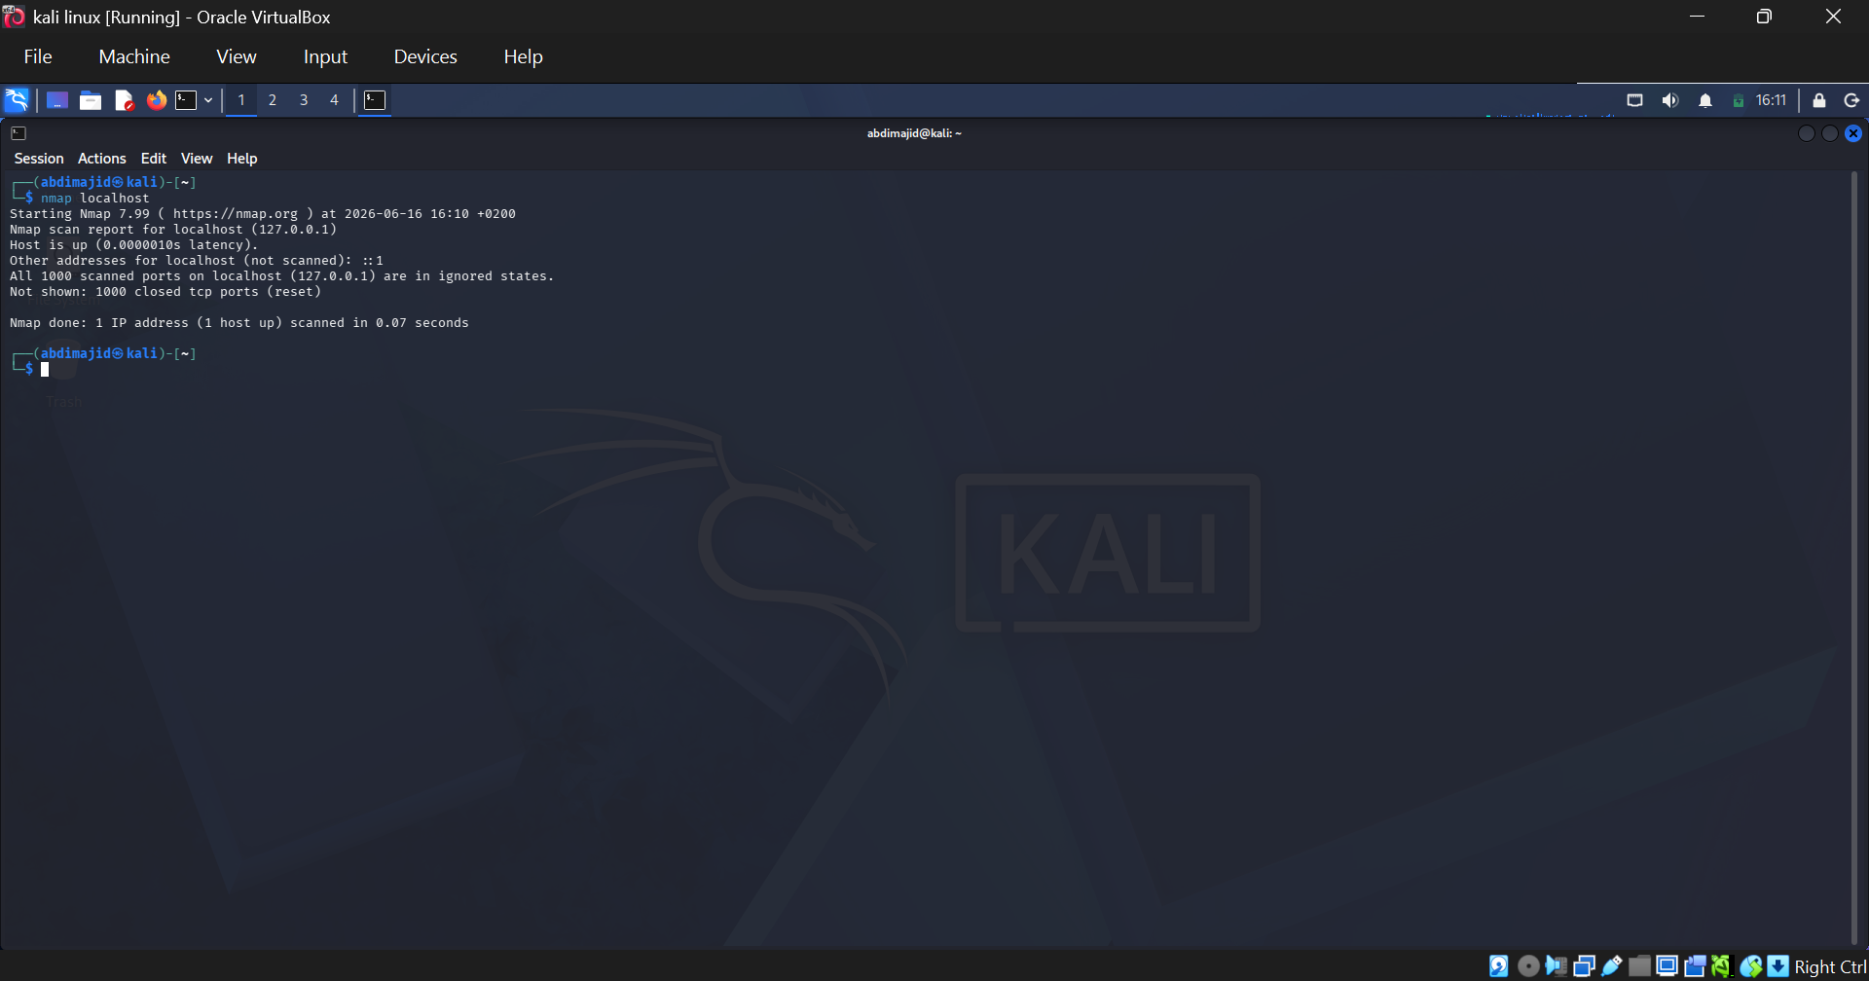
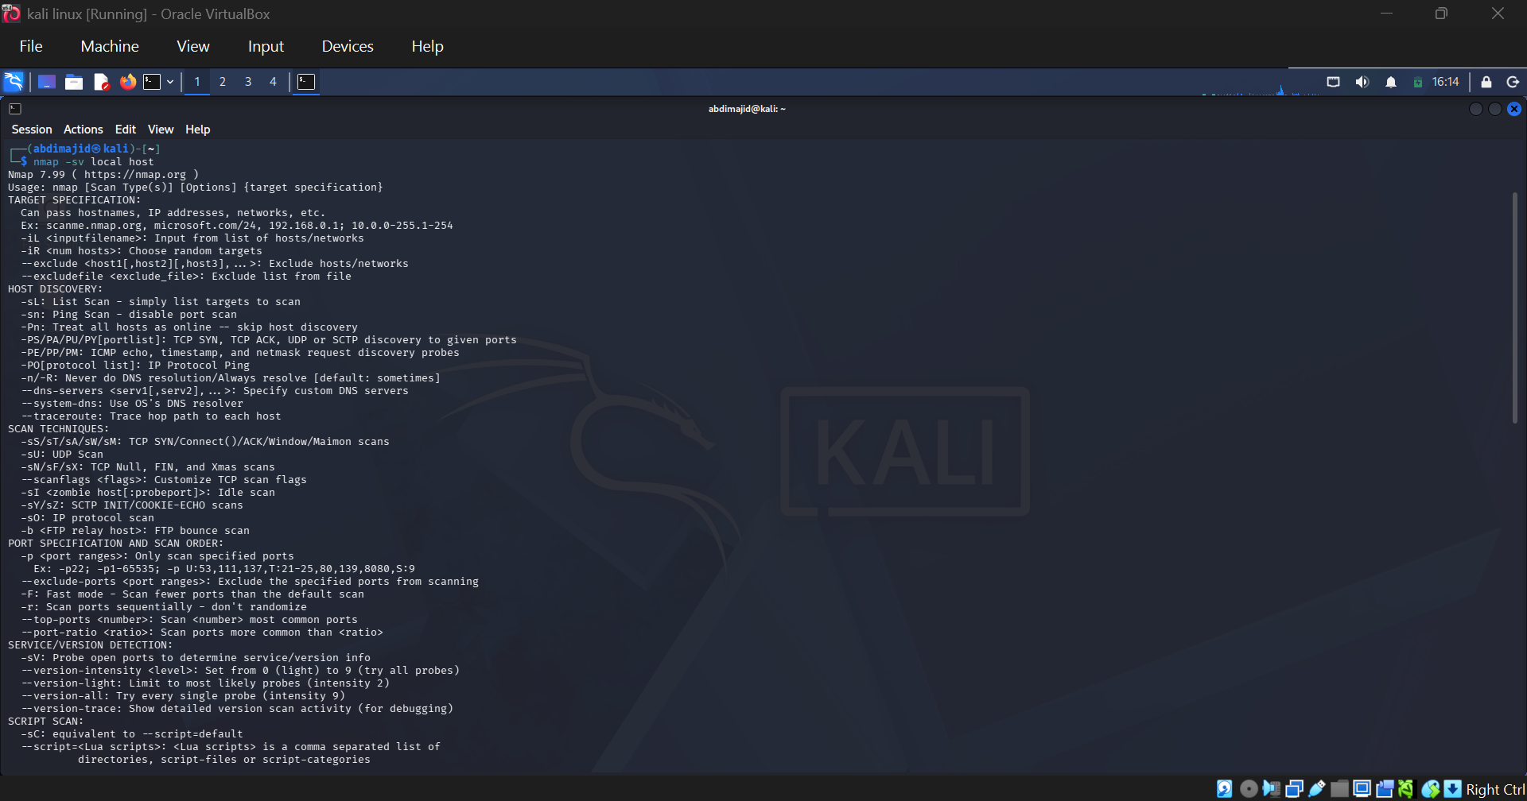
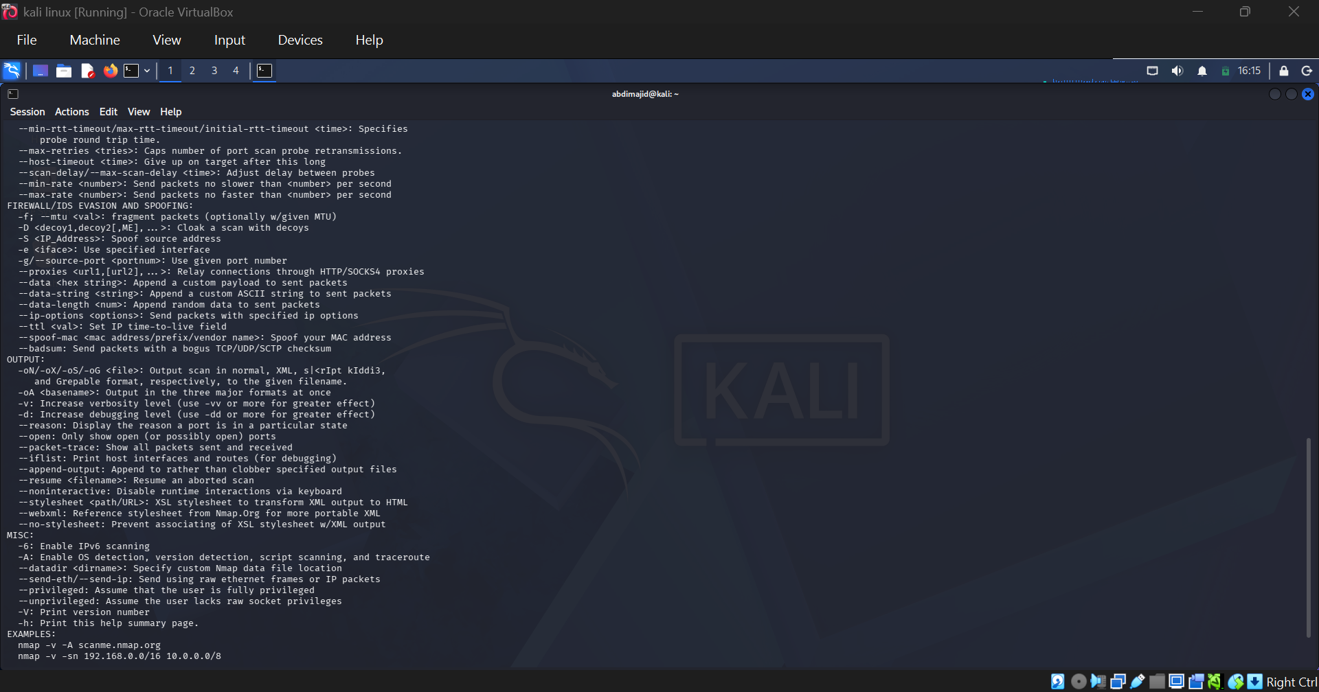
3. Recommended Security Improvements
- Implement Service Hardening: Modify the service configurations (sshd_config, httpd.conf) to suppress version banners, hiding exact deployment specifics from unauthorized recon scans.
- Restrict Access Bindings: Ensure that internal services like MySQL are explicitly bound to 127.0.0.1 only and not exposed to the broader external interfaces.
- Keep Software Up-to-Date: Regularly run system update sequences to upgrade network-facing binaries to their latest patched releases.
Part 3: Practical Task 2 – Vulnerability Research Assignment
Below are five distinct vulnerabilities spanning various modern protocols, application frameworks, and operational architectures:
1. CVE-2021-44228 (Log4Shell)
- Description: An unauthenticated Remote Code Execution (RCE) flaw in Apache Log4j's JNDI lookup feature.
- Severity: Critical (CVSS 10.0)
- Potential Impact: Complete system takeover. Attackers can pass a malicious string via simple request inputs, forcing the server to load and execute arbitrary code hosted on an external untrusted server.
- 2. CVE-2023-38606 (Apple WebKit Memory Corruption)
- Description: A validation flaw within WebKit that permits malicious web content to trigger arbitrary state execution.
- Severity: High (CVSS 8.8)
- Potential Impact: Drive-by download compromises. An attacker can construct a malicious webpage that executes code on a target mobile device or workstation when visited.
- Mitigation Strategy: Apply current operating system patches across all client endpoints (iOS, iPadOS, macOS updates).
3. CVE-2024-21626 (runc Container Breakout)
- Description: An internal file descriptor leakage in runc that allows processes inside a container to access the host filesystem.
- Severity: Critical (CVSS 8.6)
- Potential Impact: Host environment breakout. Attackers running containerized software can breach isolation walls to access sensitive host files and configurations.
- Mitigation Strategy: Update container engines (docker, containerd) to incorporate runc version 1.1.12 or later.
4. CVE-2022-22965 (Spring4Shell)
- Description: A remote code execution flaw in the Spring Framework involving improper parameter binding over specific Java Development Kit layouts.
- Severity: Critical (CVSS 9.8)
- Potential Impact: Attackers can pass crafted HTTP requests to overwrite critical server parameter attributes, dropping web shells onto application web roots.
- Mitigation Strategy: Upgrade the Spring Framework codebase to versions 5.3.18 or 5.2.20 and use modern patched JDK baselines.
5. CVE-2023-49103 (ownCloud Graph API Vulnerability)
- Description: An exposure of administrative credentials and environmental variables through a structural web endpoint within ownCloud extensions.

- Severity: Critical (CVSS 10.0)
- Potential Impact: Exposure of PHP environment credentials, including master database passwords, object store access keys, and critical application secrets.
- Mitigation Strategy: Delete the vulnerable file component (apps/graphapi/vendor/microsoft/microsoft-graph/tests/GetPhpInfo.php) or change application secrets immediately.
Part 4: Practical Task 3 – Organizational Vulnerability Assessment Plan
This plan details a targeted blueprint tailored specifically for a Hospital Infrastructure Network, where patient safety and continuous operational uptime are paramount.

Asset Inventory ] ----> Automated discovery & classification
|
Scope & Schedule ] ----> Monthly automated scans / Off-peak schedules
|
Tools Selection Matrix ] -> Nessus (Systems) / Nikto (Web Portals)
|
Risk Assessment ] ----> Prioritized by CVSS & Impact on Patient Care
|
Reporting & Remediation ] -> Actionable tickets & Patch verification loops

1. Scope
- In-Scope Elements: Electronic Medical Record (EMR) servers, laboratory diagnostic networks, connected medical devices (IoT/IoMT), clinician workstations, and external patient appointment web applications.
- Out-of-Scope Elements: Critical life-support telemetry clusters (monitored solely via isolated continuous inline monitoring to prevent scan disruption).

2. Tools Selection
- Network Infrastructure: Nessus (for authenticated vulnerability checks across infrastructure hosts and operating systems).
- Web Application Layers: Nikto (for auditing internal portal endpoints and medical information web pages).
- Ad-hoc Audits: Nmap with NSE scripts (for fast target verification during localized maintenance windows).
3. Schedule & Operations
- Automated Scanning: Monthly full network scans executed during low-activity windows (Saturdays between 02:00 AM and 04:00 AM EAT) to minimize impact on patient triage services.
- Continuous Monitoring: Weekly passive asset discovery runs to spot rogue access points or uninventoried connected devices.
4. Reporting Procedure
- Executive Briefings: High-level threat vector summaries showing the historical drop in open critical bugs, tailored for presentation to hospital directors.
- Technical Engineering Reports: Detailed actionable tickets delivered straight to system admins, sorting flaws by CVSS scores and mapping out exact mitigation patches.
Part 5: Advanced Practical Task – Vulnerability Tracking Framework
Below is the structured data configuration representing real-world vulnerability lifecycle workflows. You can easily convert this structure directly into an Excel sheet or a markdown table for your project records:
Vulnerability Tracking Matrix
Vulnerability Name | CVE ID | Affected Asset | Risk Level | CVSS | Patch Status | Assigned Personnel | Target Resolution Date | Actual Resolution Date
SQL Injection in Portal | CVE-2024-XXXX | EMR Web Server | Critical | 9.8 | Open | Lead Web Developer | June 18, 2026 | —
Outdated Apache Banner | CVE-2023-YYYY | Public Web Gateway | Low | 3.5 | Resolved | Network Engineer | June 25, 2026 | June 15, 2026
SSH Brute Force Risk | N/A | Lab Domain Controller | High | 7.5 | In Progress | System Administrator | June 20, 2026 | —
Windows SMB Flaw | CVE-2024-ZZZZ | Triage Workstations | Critical | 8.8 | Resolved | IT Support Team | June 15, 2026 | June 14, 2026

